Hillstone SNMP 配置指南

CLI
interface + 接口
manage snmp

snmp-server manager
snmp-server port 161
snmp-server engineID “string”
snmp-server group group-name v3 { noauth | auth | auth-enc} [ read-view
read-view] [ write-view writeview]
snmp-server user user-name group group-name v3 remote remote-ip
[ auth-protocol { md5 | sha} auth-pass [ enc-protocol { des | aes} enc-pass]]
snmp-server host “host-name” version 1 community “string” ro
snmp-server host“host-name” version 2c community “string” ro
snmp-server host “host-name” version 3
snmp-server trap-host “host-name” version 1 community “string” port 162
snmp-server trap-host “host-name” version 2c community “string” port 162
snmp-server trap-host “host-name” version 3 user “string” engineID “string” port 162

WEB
在接口下开启SNMP功能

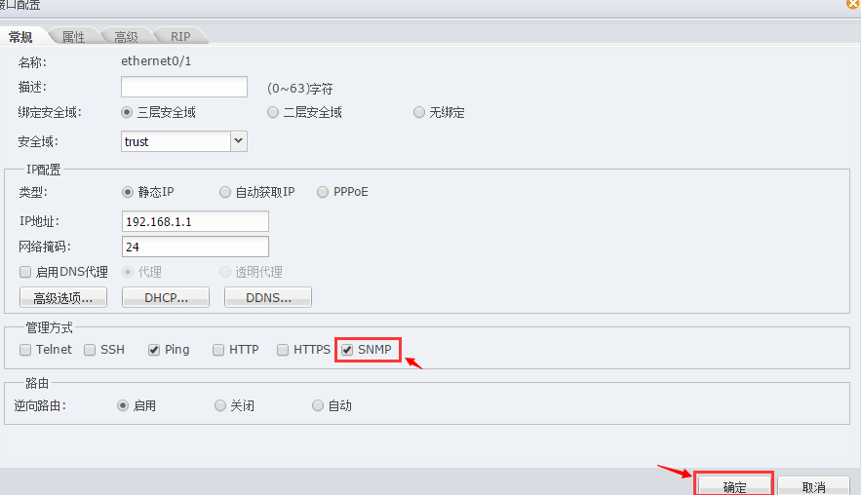

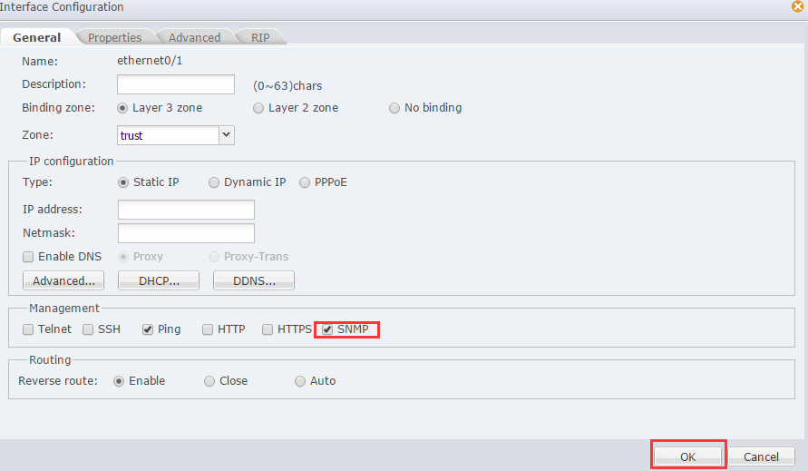
开启SNMP代理功能
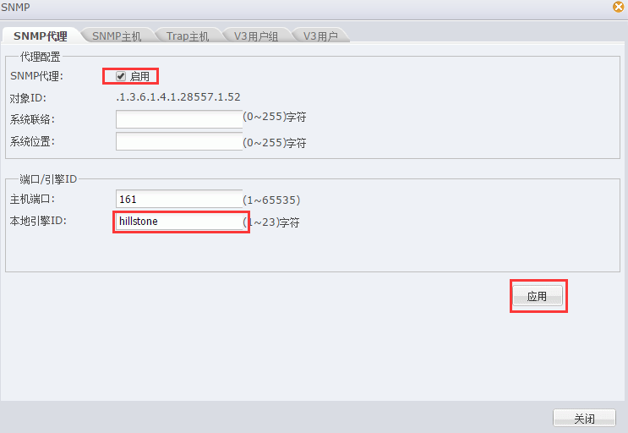
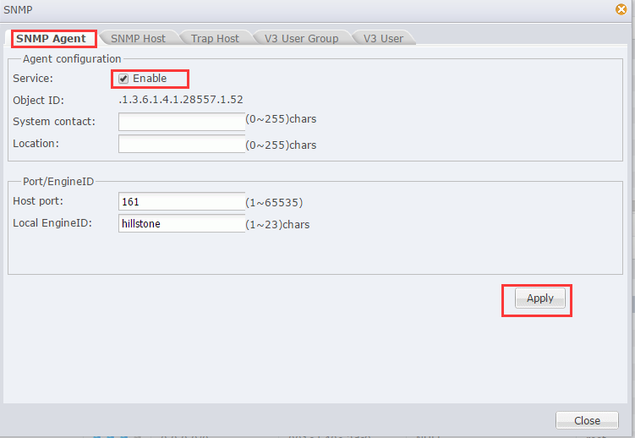

添加SNMP V1主机
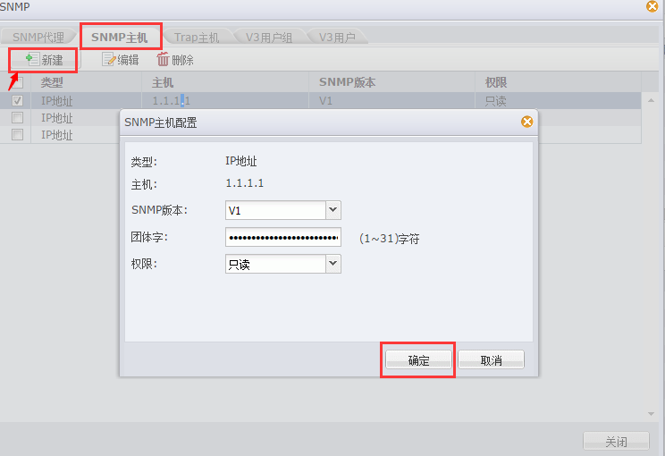

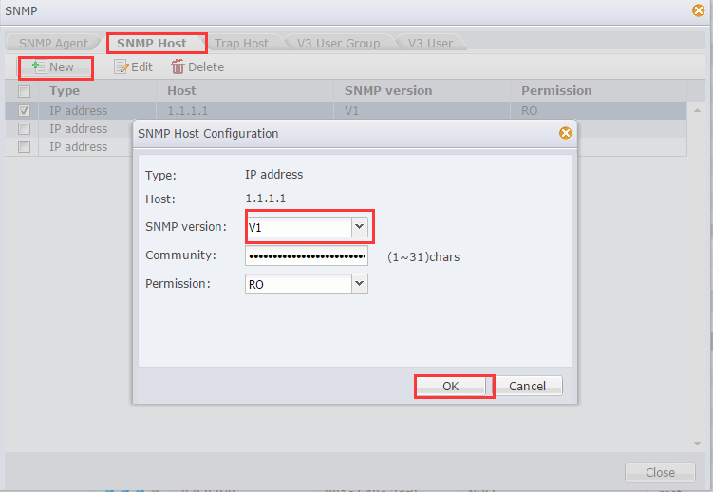

添加SNMP V2主机

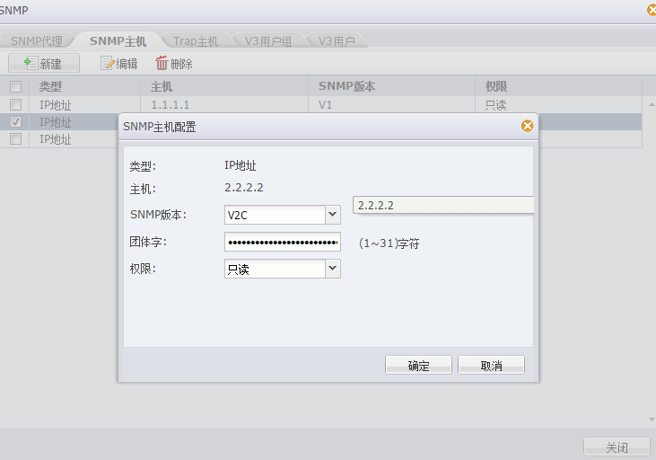

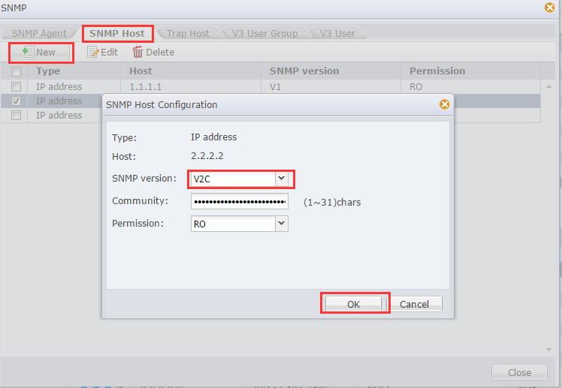

添加 SNMP V1 trap主机
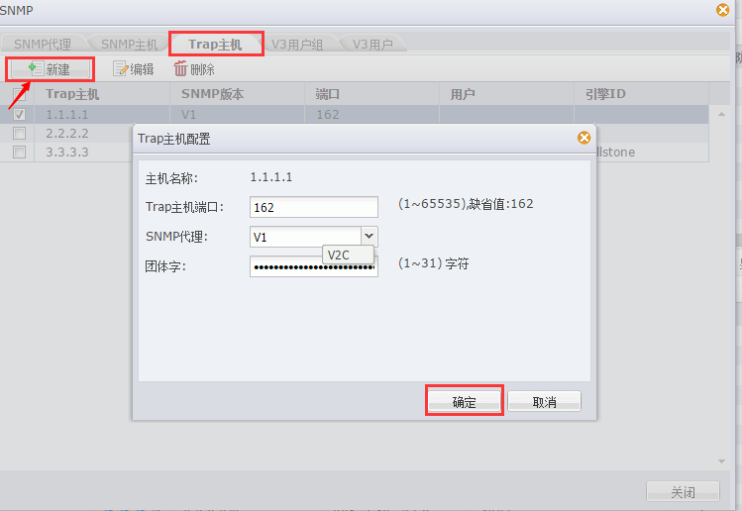
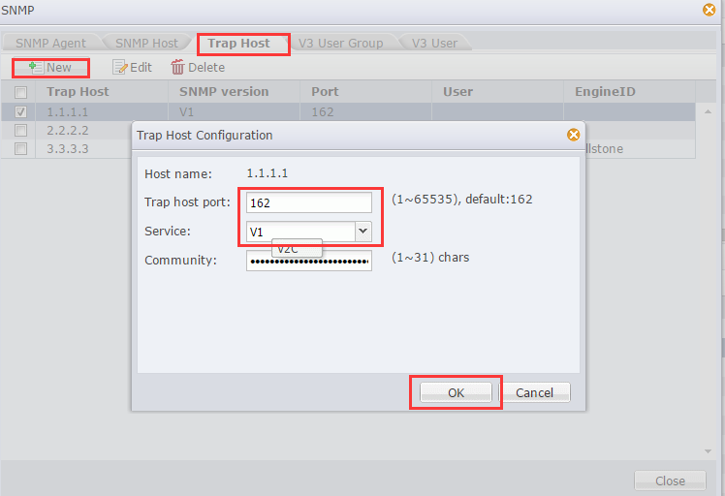

添加 SNMP V2 trap主机

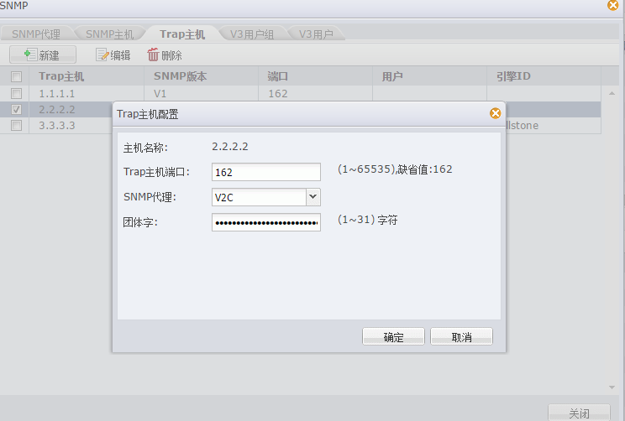

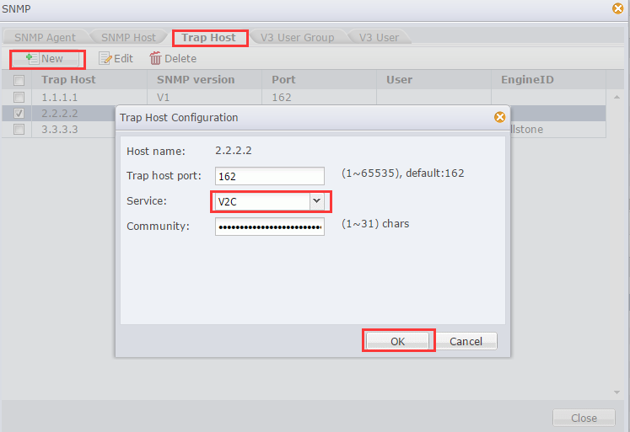

添加 SNMP V3 trap 主机

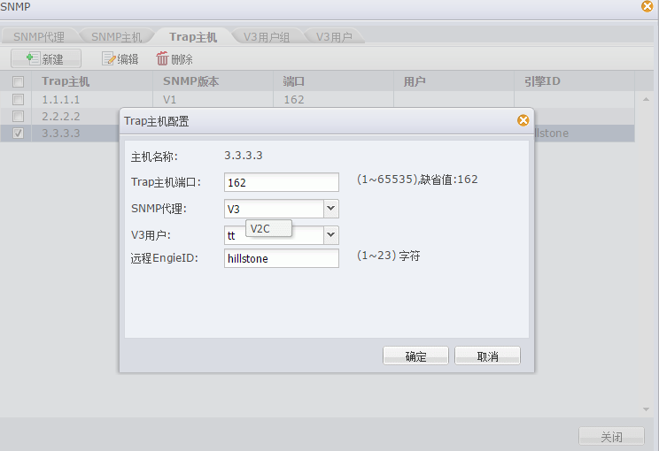

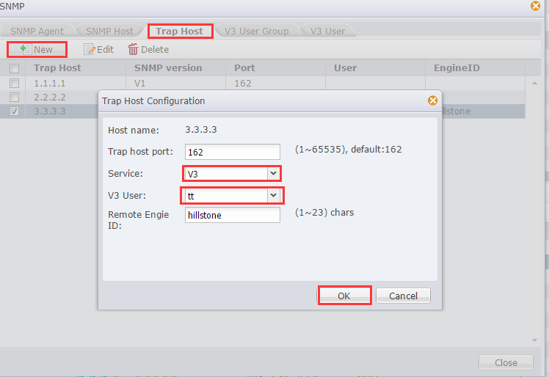

添加SNMP V3用户组
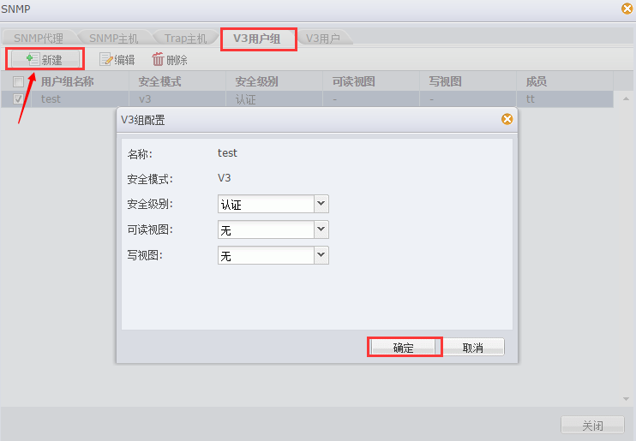

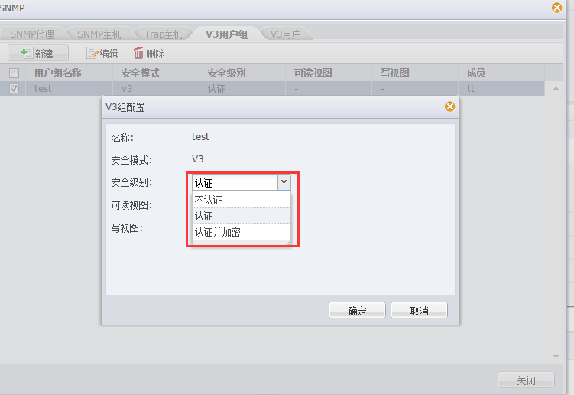
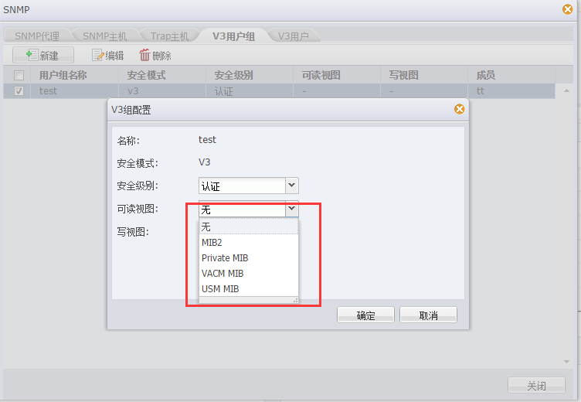
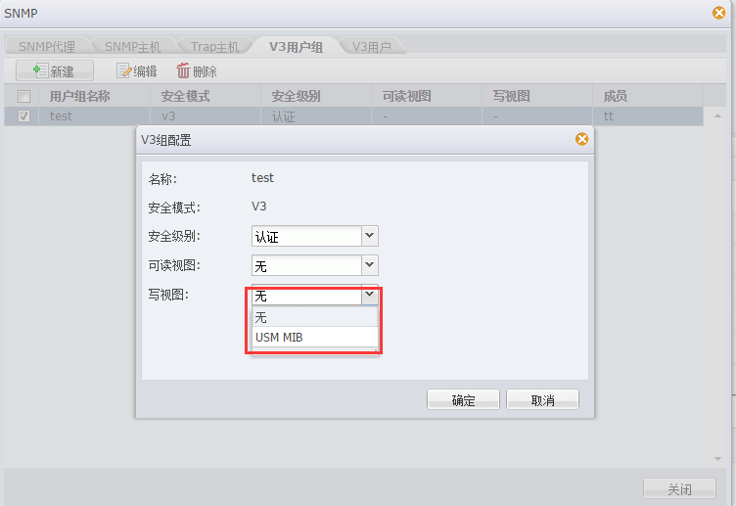
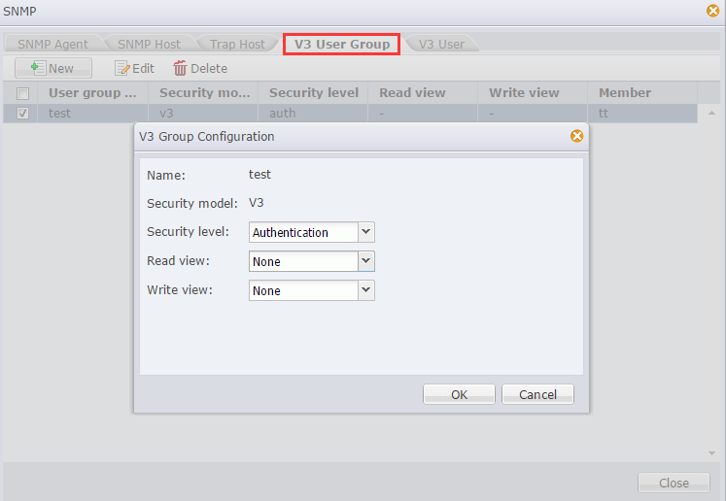

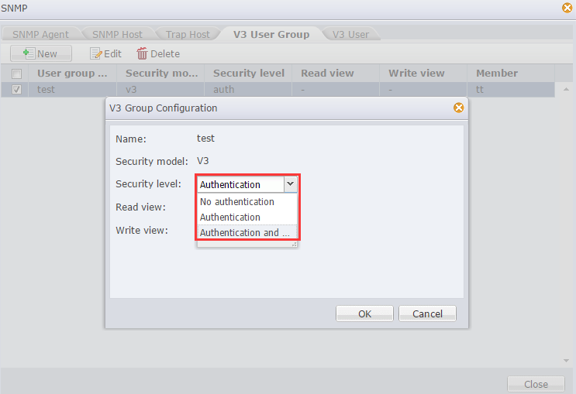
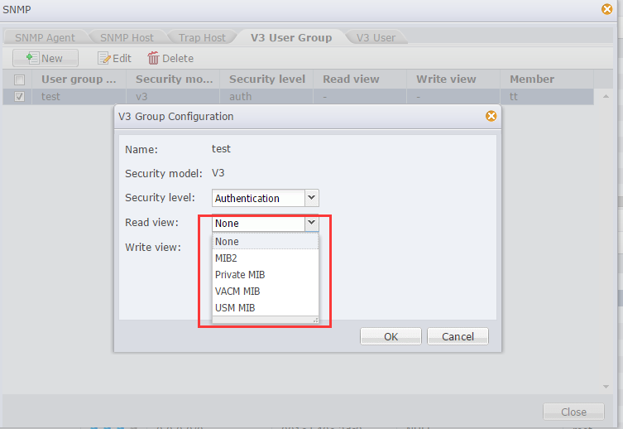
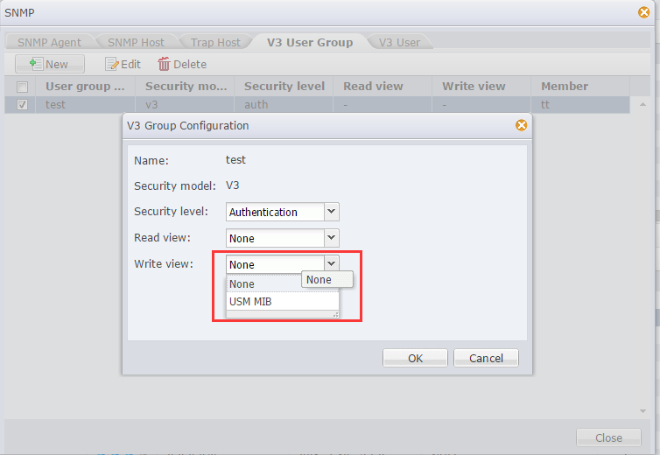

添加 SNMP V3用户
